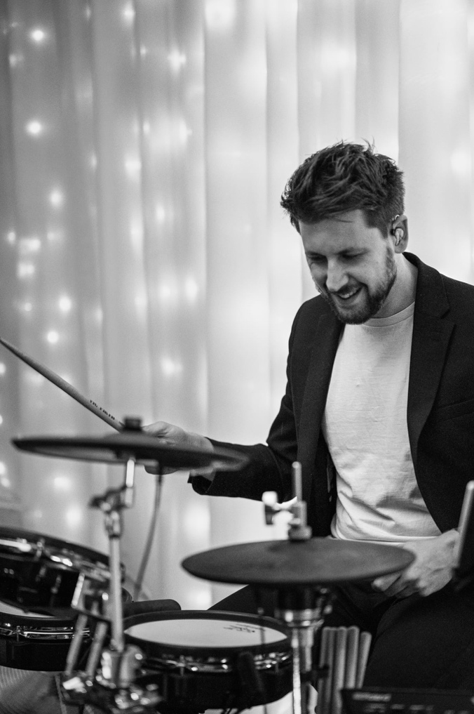
Luke Pettit – Drummer
Contact Information
- www.lukepettitdrums.com
- lukepettitdrums@gmail.com
- 07883 992495
- Woodbridge, Suffolk, UK

Instruments:
Gretsch and A&F drums, Istanbul Agop cymbals,
Roland V-Drums (TD-30 & SPD-30)

Current Performance Work
- Drummer for UK function band StereoJack
- Drummer for UK singer-songwriters Millie Kirkpatrick and James Morgan
- Theatre pit band
- Reliable and prepared dep
- Music performance lecture at Suffolk New College and West Suffolk College
- 1-2-1 Drum Tutor at Planet Music Academy

Has worked with:
Enchanted Entertainment Pantomimes, Griff Rhys Jones Christmas Show @ Ipswich Regent, Ruthie Henshall’s CAST, CON East, Suffolk Young People’s Theatre, Viva! Arts, The Edinburgh Fringe, Theatre Royal Bury St Edmunds, and many more…

Qualifications

PGCE – University of Suffolk, 2021
BMus (Hons) Professional Music Performance (Drums) Degree 2:1 from the Academy of Contemporary Music, 2016

Holds Valid Passport, UK Driving Licence and clear DBS

References

Paul Schofield  Musical Director (various)  07543 858395  paul@threepinproductions.com | Vicky Calver  Musical Director (theatre)  07882 450571  calver.vicky@gmail.com | Ward Baker  Musical Director (pantomime)  07850 941831  wardbaker55@gmail.com

